Lab 7
Question 1.
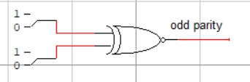

Question 2.
Enable | A₁ | A₀ | D₀ | D₁ | D₂ | D₃
1 | X | X | 0 | 0 | 0 | 0
0 | 0 | 0 | 1 | 0 | 0 | 0
0 | 0 | 1 | 0 | 1 | 0 | 0
0 | 1 | 0 | 0 | 0 | 1 | 0
0 | 1 | 1 | 0 | 0 | 0 | 1

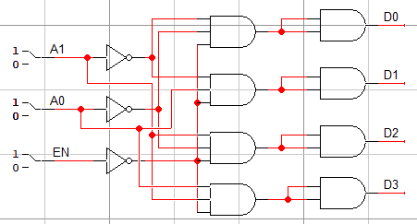

Question 3.
